# *Database Management I (420-D10-HR)*

# *Lab 01 – Introduction to Databases*

Date assigned: Monday August 22, 2016

Date due: **Monday August 22, 4:50pm**

### Name: ______________________

### Marks:

|  |  |  |  |
| --- | --- | --- | --- |
|  | **Section** | **Mark** | **Out Of** |
| 1 | Outlook setup – calendar setup, populated and shared |  | 10 |
|  | H: drive setup with course folders |  | 10 |
|  | PEA refresher |  | 10 |
| 2.1 | Paper Database Exercise (query)– role-based questions |  | 14 |
|  | Paper Database Exercise – questions (all roles) |  | 6 |
| 2.2 | Paper Database Exercise (updates)– role-based questions |  | 14 |
|  | Paper Database Exercise (updates)– questions – all roles |  | 6 |
|  | Organization – handed into Moodle correctly, proper use of english |  | 5 |
|  | **Total** |  | **75** |

**Learning Objectives**

Upon successful completion of this lab exercise, the student will be able to:

1. Set up course folders.
2. Set up Outlook on the desktop.
3. Enter a timetable in Outlook.
4. Examine the co-op eligibility requirements for second year
5. Examine the PEA requirements
6. identify some of the problems with traditional file based systems
7. explain some of the negative side-effects of data duplication
8. explain some of the benefits of data sharing

**To uploaded Moodle:**

1. The ***username_*D10_L01_Intro.doc** file completed as instructed in the lab.

**To Start:**

1. Fill in this document with your solutions then submit to moodle.

**Part 1 – Environment setup**

**Part 1.1 – Read the Fall 2016 notice from Computer Services**



**Part 1.2 - Microsoft® Outlook Set Up**

1. Start Microsoft Outlook 2013 by selecting **Start, Programs, Microsoft Office, Microsoft Office Outlook 2013** or using the icon in the task bar or desktop. The Outlook Startup window will open. Click Next.

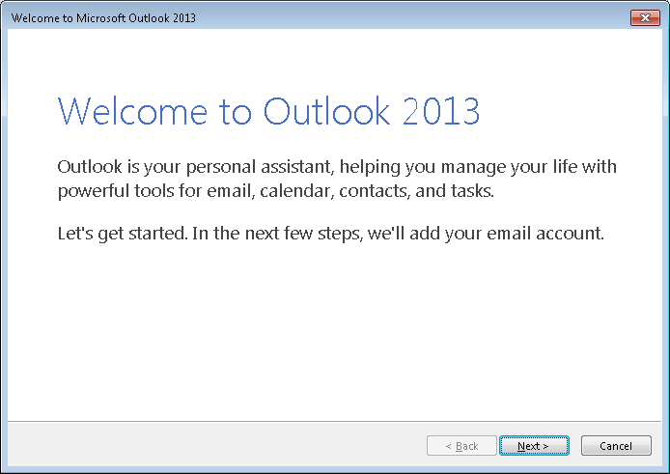

1. The next window asks you to confirm that you want to set up an account. Make sure the Yes option is highlighted and click Next.  
     
   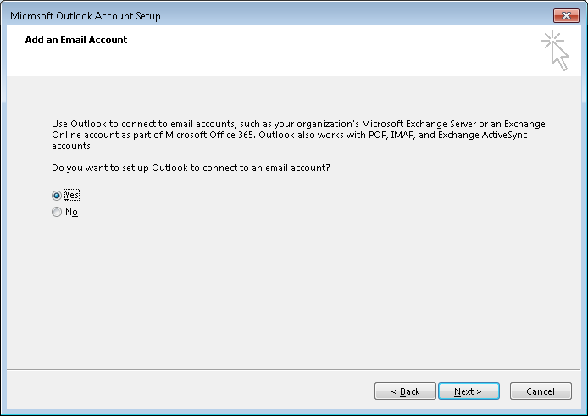
2. The Add New Email Account screen is displayed. Your name and email address should be filled in by default. If your name is not automatically filled in, add your email address in the Email address field. Your email address is your studentId with @cegep-heritage.qc.ca added to it. Your userId and Password will be the same as your Omnivox setup.

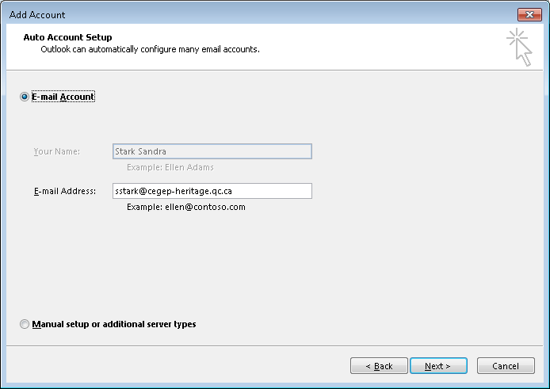

1. Click **Next**. Your email account should be successfully set up now:

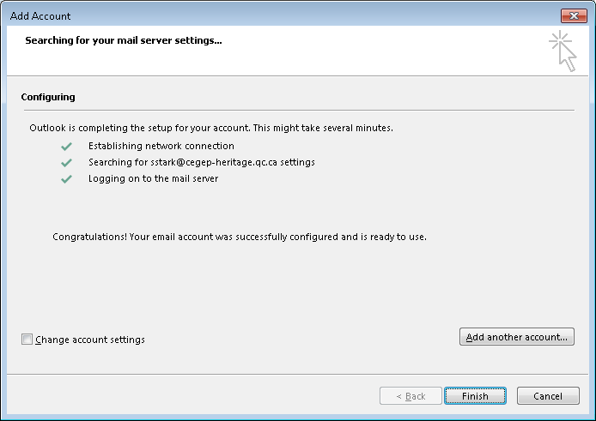

**If you do NOT receive the above screen, let me know immediately. Do NOT click finish. We may have to set up your account manually.**

1. Click **Finish**. Outlook 2013 will now open.

***Note***: You have set up your profile on the desktop computer. The next time you use this computer, simply open Outlook and select your profile.   
  
If you use another computer, you will have to repeat this procedure to set up your profile there.

**Part 1.3 - Calendar Set Up**

1. If it is not already started, start Microsoft® Outlook 2013 by selecting Start, Programs, Microsoft Office, Microsoft Office Outlook 2013 or using the icon in the task bar or desktop.
2. Select **Calendar** at the bottom of the screen and change the view to be **Week** by selecting the tab below the tool bar.
3. Set up your timetable by repeating the following steps for each course block in your timetable.
   1. Starting with Monday, August 22, select a block of time that corresponds to the course and then select **New Appointment** on the shortcut menu.
   2. Select the **Recurrence** option and ensure that the Appointment Recurrence is set up as follows:
      1. The Start and End time should be the starting hour and ending hour for the block in your timetable. The end time should not be changed to be 10 minutes before the hour. The Duration is automatically calculated.
      2. The Recurrence pattern should be weekly, and the appropriate day should be checked.
      3. Set the **Range of recurrence** to **End after: 16** occurrences, for courses on Monday, Tuesday or Wednesday and **15** for courses on Thursday or Friday. Click **OK**.
   3. In the **Subject** box, type the name of the course.
   4. In the **Location** box, enter the room number.
   5. In the top ribbon bar, set the Reminder (the bell icon) for the entry to be None.
   6. Click **Save and Close**.
4. Change your Outlook calendar to match the academic calendar as follows:
   1. Delete the occurrences on Labour Day (September 5) by selecting all the blocks on that day, selecting Delete from the shortcut menu, and ensuring that **Delete this occurrence** is selected.
   2. Delete the occurrences on the Wednesday after Thanksgiving (October 12) by selecting all the blocks on that day, selecting Delete from the shortcut menu, and ensuring that **Delete occurrence** is selected.

### Move the occurrences from Thanksgiving Monday (October 10) to the Wednesday after Thanksgiving (October 12) by double clicking the appointment and changing the date. Make sure that Open this occurrence is selected. You can also drag and drop the occurrence to the new day, in which case you will be prompted to confirm that you are changing only the occurrence. Select Yes.

* 1. Delete the occurrences on Tuesday November 1, by selecting all the blocks on that day, selecting Delete from the shortcut menu, and ensuring that **Delete occurrence** is selected.

### Move the occurrences from Friday November 4 (Study day) to Tuesday November 1 by double clicking the appointment and changing the date. Make sure that Open this occurrence is selected. You can also drag and drop the occurrence to the new day, in which case you will be prompted to confirm that you are changing only the occurrence. Select Yes. Mark Friday November 4 as a study day.

1. While viewing your calendar click on the ShareCalendar button on the menu bar.

Share your calendar with the user **#Teaching Staff Computer Sciences** (all the Computer Science teachers). Under Details, select “Full Details”

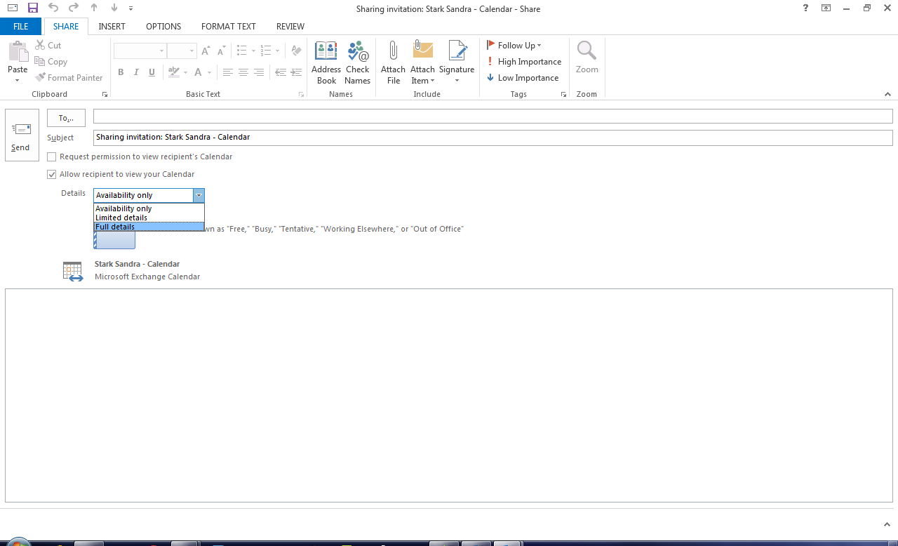

Click **Send**.  
This will allow teachers to view your calendar.

**Part 1.4: Set up Course Folders**

## Double-click on the My Computer icon at the upper left hand corner of the desktop. This opens Windows Explorer for the computer and network drives accessible to you.

## Double-click on the H: drive icon. This is your home drive. It is also where My Documents will take you.

## Select File🡪 New 🡪 Folder from the menu bar.

## Replace the words New Folder with 420-E11.

## Repeat steps 3 and 4 for 420-C30, 420-D10 and 420-B31

## Double-click on 420-E11. Create two new folders here – call one Labs and the other one Assignments.

## Repeat step 6 for folders 420-C30, 420-D10 and 420-B31.

1. If you have any files on your OLD H: drive from last semester, you’ll have to log off from your account (based on the student ID), log back on with your old username, copy off the files your want (either to a USB or locally on the machine), log back on using your studentId and copy back your old files in. The old username based accounts will be deleted early in the semester.

# Part 1.5: Co-op and PEA Refresher

1. Go to the Student Resources page in Moodle.
2. Open the document called “Co-op Program and Eligibility.”
3. To be eligible for a co-op placement after second year, what are the requirements for English courses?
4. What is the minimum average required in second year and on which courses?
5. If you do not meet the requirements for co-op, what option do you have and how do you go about it?
6. How many requirements (in total) are there for second year co-op eligibility?
7. On the Student Resources page in Moodle, open the document “Program Exit Assessment.”
8. What is the purpose of the program exit assessment (PEA)?
9. In which course do you work on the draft version of your Program Exit Assessment?
10. What must you prepare in order to complete the Computer Science PEA?
11. What must you submit to the department in order to have your PEA assessed?
12. Who performs the assessment of your PEA?
13. If you do not pass all the objectives of the PEA, what are two possible options for a make-up?

# Part 2.1 - Paper (non-relational) database exercises - query

***To Do:***

The class will be divided into teams of four students.

Each team will be given four different sets of paper files to work with. Each team member will take “ownership” of one set of files. Each set of files contains information gathered and used by different sectors of a small college: the registrar’s files, the admissions officer’s files, the academic dean’s files or the loan officer’s files.

Using the files you have responsibility for, answer the appropriate questions below.

***The Registrar’s Files***

1. Give the student number and name of all students registered in 420-E10-HR

|  |  |
| --- | --- |
| **Student Number** | **Student Name** |
| Jerry Atrix | 0001114 |
| Ella Fant | 5550123 |
| Eileen Over | 5551111 |
| Mike O’Phone | 5555555 |
| Ivor Good | 5653200 |
| Dan Yell | 5553200 |
| Sam Sham | 5653201 |

1. A student may register when they present a confirmation of admission card similar to the following:

***Student Admission Confirmation***

**The following student has been admitted to the College.**

***Student Number*** 020-1111 ***Student Name*** Paddy O'Furniture

***Student Address*** 26 Oak St.

***Student Phone*** 555-2312

***Program*** 420 Computer Science

Create a registration record for the above student. Register him in 1st year in courses 420-B10-HR (Programming I), 420-A10-HR (Operating Systems) and 420-C10-HR (Web Programming I) for the Fall, 2002 semester using the blank registration form in the folder.

1. How many students are registered in Social I? _3________________

***The Admissions Officer’s Files***

1. Give the student number and name of all students who have been admitted from D'Arcy McGee High School.

|  |  |
| --- | --- |
| **Student Number** | **Student Name** |
|  |  |
| **0201113** | Tom Thumb |
| **9902222** | Sue Yu |
| **5551113** | Cash Carry |
| **0001114** | Jerry Atrix |
| **5551112** | Sam Sham |
|  |  |
|  |  |
|  |  |
|  |  |

1. Complete the blank application form found in the file for yourself.
2. What is the average high school math mark for all students admitted to Computer Science, regardless of whether Computer Science is their first, second or third choice? ______71.39________________

***The Academic Dean’s*** ***Files***

1. Give the course number, course name and teacher of all courses in the ECCE department (i.e. the course number begins with 322) for the Fall, 2001 semester.

|  |  |  |
| --- | --- | --- |
| **Course Number** | **Course Name** | **Teacher** |
| **322-H01-HR** | **ECCE1** | **Polly Morphek** |
| **322-H03-HR** | **ECCE3** | **Al Dente** |
| **322-H05-HR** | **ECCE5** | **Al Dente** |
|  |  |  |

1. Complete the blank teacher workload form for a new teacher – Joe Daze (teacher number 450). He will be teaching three new courses in the fall 2002 semester – 204-CYA-03 *Why Computers*, 204-CYB-03 *Life in Cyberspace* and 204-CYC-03 *Dot Com Fortunes*.
2. How many hours a week is Sam Ovar scheduled to teach in the Winter, 2003 semester? ___7_____________

***The Loan Officer’s*** ***Files***

1. Give the student number and name of all students who were over 21 years old in 2002 who have a student loan in 2002.

|  |  |
| --- | --- |
| **Student Number** | **Student Name** |
|  |  |
|  |  |
| **0201114** | **Fanny Farmer** |
| **0101111** | **Dan Yell** |

1. Use the blank loan application form in the folder to create a loan application for student 1111 – Dwight Wong. His birthday is Feb 17, 1986. His parent’s income is $50,000.
2. What is the average loan (not grant) amount for all students who received a student loan in 2002? ____10,000.00_________

***All Files***

***Questions:***

1. What is the main subject(s) of the records in your file folder? _______________
2. What type of information do you have for your subject in the file folder?

________________________________________________________________

1. Which of the types of information that you found in 2 uniquely identify each subject?

________________________________________________________________

1. Compare your answer to 2 with other students who have the same role. What differences if any were there?
2. Refer to the files your were given and using the following definitions:

A ***field*** is the smallest unit of named application data recognized by system software. It is a character or group of characters (alphabetic or numeric) that has a specific meaning.

A ***record*** is a logically related set of one or more fields that describes a person, place or thing.

A ***file*** is a collection of related records.

* 1. give an example of a field _____________________________________
  2. give an example of a record ________________________________
  3. give an example of a file _____________________________________

# Part 2.2 - Paper (non-relational) database exercises -updates

Use the files you have responsibility for to answer the appropriate questions below. If you are unable to answer the question with the information in your files, explain why. If necessary, refer to the files of any of your teammates for the answer. Indicate who had the additional information.

***The Registrar’s Files***

1. Give the student number and name of all students who are registered for more than 1 course and who have a student loan for 2002.

|  |  |
| --- | --- |
| **Student Number** | **Student Name** |
| **5551112** | **Sam Sham** |
| **0001115** | **Ella Fant** |
|  |  |
|  |  |
|  |  |

1. Change Sue Yu’s name to Sue Wu.

***The Admissions Officer’s Files***

1. Give the student number and name of all students from Philemon Wright High School who are registered in 200-H03-HR

|  |  |
| --- | --- |
| **Student Number** | **Student Name** |
|  |  |
|  |  |
|  |  |
|  |  |

1. Change Sue Yu’s address to 99 Wandering Way.

***The Academic Dean’s*** ***Files***

1. What classes did Mary Lamm teach Ella Fant? Give the course number, name and semester.

|  |  |  |
| --- | --- | --- |
| **Course Number** | **Course Name** | **Semester** |
|  |  |  |
|  |  |  |
|  |  |  |
|  |  |  |

1. Remove 322-H02-HR from Al Dente’s workload.

***The Loan Officer’s*** ***Files***

1. Give the student number and name of all students who have a student loan and who went to D’Arcy McGee High School.

|  |  |
| --- | --- |
| **Student Number** | **Student Name** |
|  |  |
|  |  |
|  |  |

1. Change Sue Yu’s phone number to 555-1020.

***All Files***

1. After you have completed as many of the previous questions as you can with the information you have been given, fill in the blanks in the following:

***Questions:***

***Student Number*** 9902222

***Name*** ___________________________________________

***Address*** ___________________________________________

***Phone Number*** ___________________________________________

1. Were there any questions you could not answer? If so, why? Who had the information you required?

________________________________________________________________

________________________________________________________________

________________________________________________________________

1. What are some possible problems resulting from the fact that Sue Yu’s information is stored in three different places?